1. Watch the video and write down notes
2. Execute all the commands shown in video.

>>>

**creating a file an empty git repositirory ,**

**checking the status,**

**adding the files,**

**commiting it .**

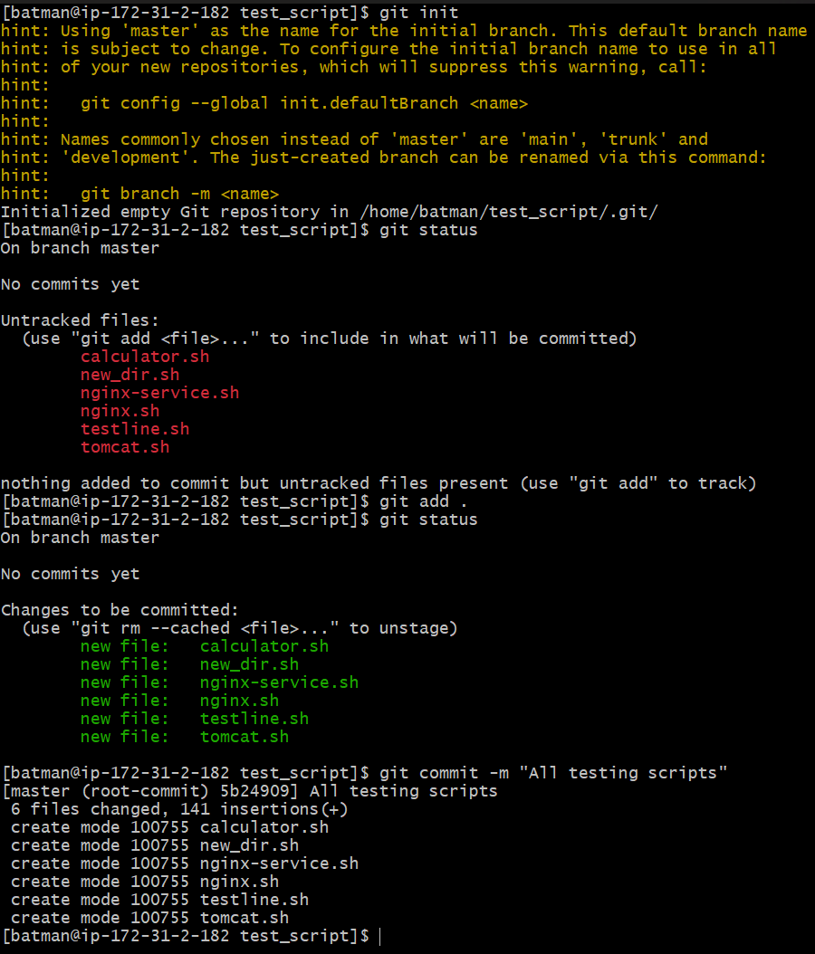

>>Creating new script ,

commiting it,

Checking logs

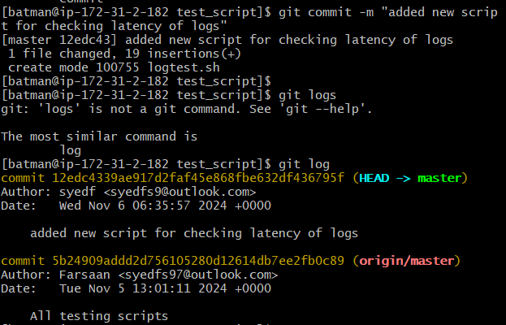

>>checking available addresses



>>Adding remote origin ,

Creating a key for ssh,

pushing the files to github,

Checking status,

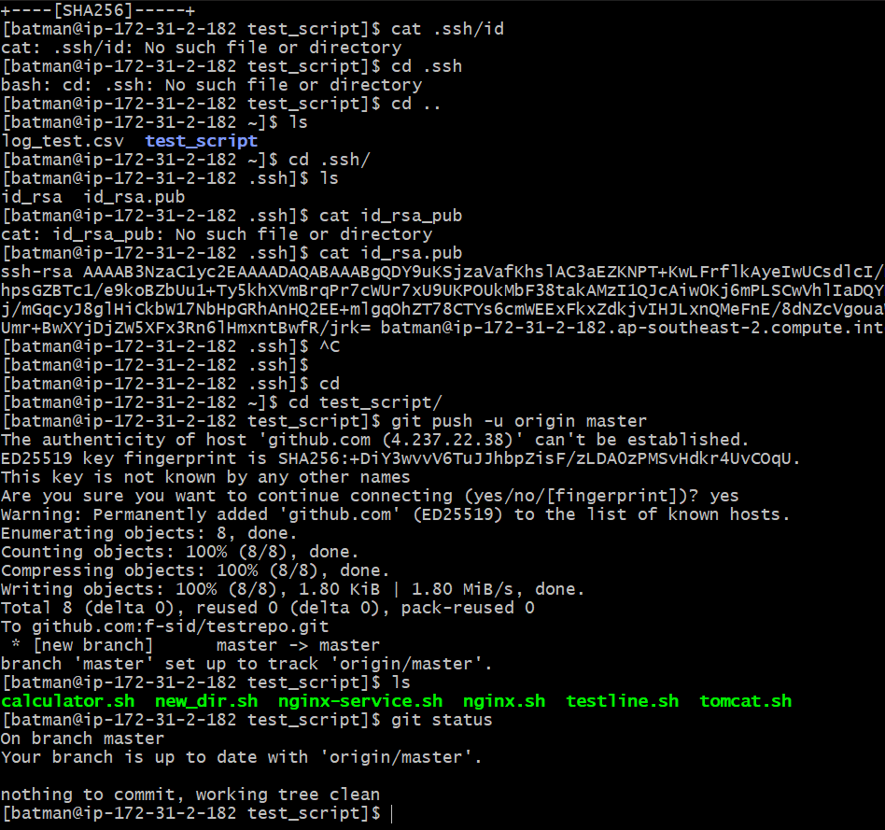

>>adding remote origin

[batman@ip-172-31-2-182 test_script]$ git remote add origin git@github.com:f-sid/testrepo.git

>>creating a github account,

Checking for files pushed from server.

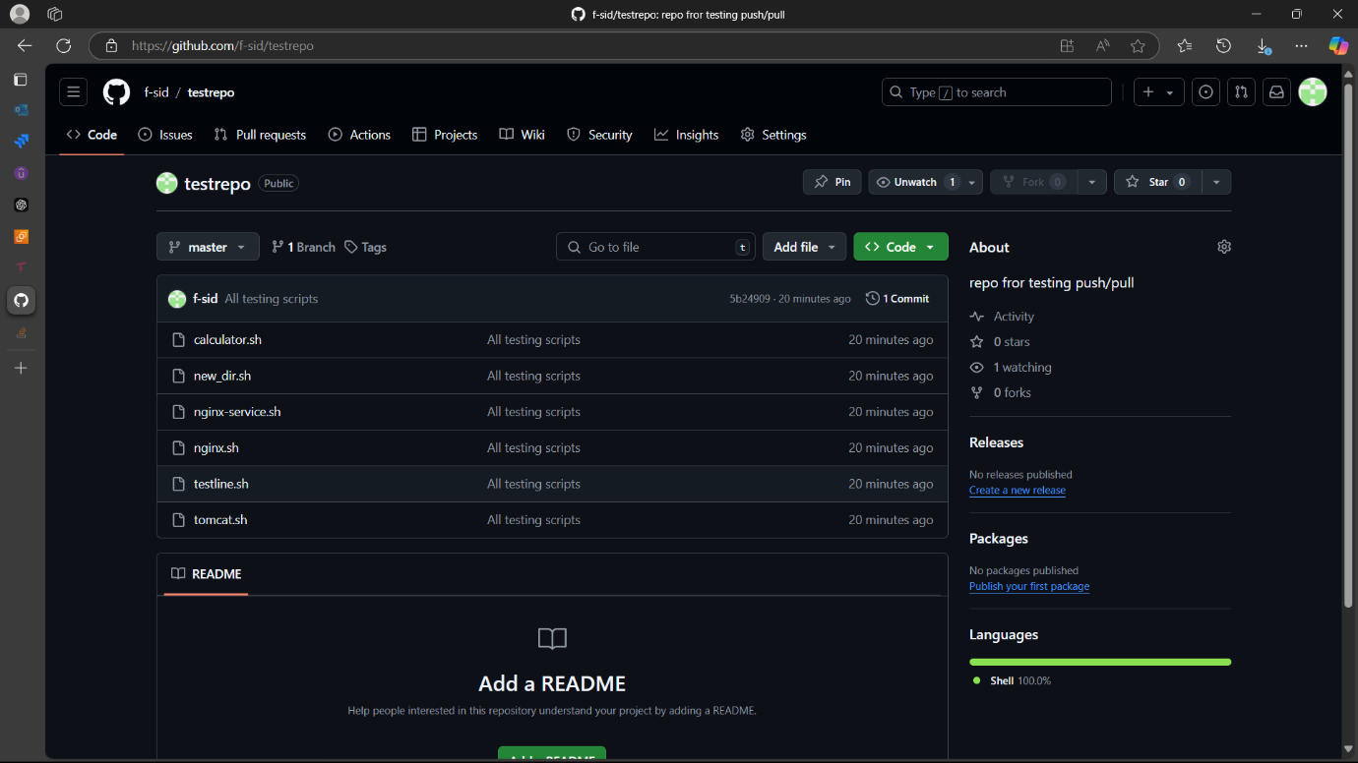

**>>If want to revert back changes made we can use git revert <commit ID>**

